ROLL NO: TYITB70 Name: Prathamesh Anil Patil

CODE:

import java.util.Scanner;

class EzPrinter{

private boolean endLine=false;

static EzPrinter obj = null;

public static EzPrinter getEzPrinter(){

if(obj == null){

obj = new EzPrinter();

}

return obj;

}

public void setEndLine(boolean value){

this.endLine = value;

}

public void print(String str){

System.out.print(str + (endLine? "\n" : ""));

}

}

class SingletonTest{

public static void main(String [] args){

EzPrinter printer = EzPrinter.getEzPrinter();

printer.print("Prathamesh Patil");

printer.setEndLine(true);

printer.print("Prathamesh Patil");

printer.print("122B2F147");

}

}

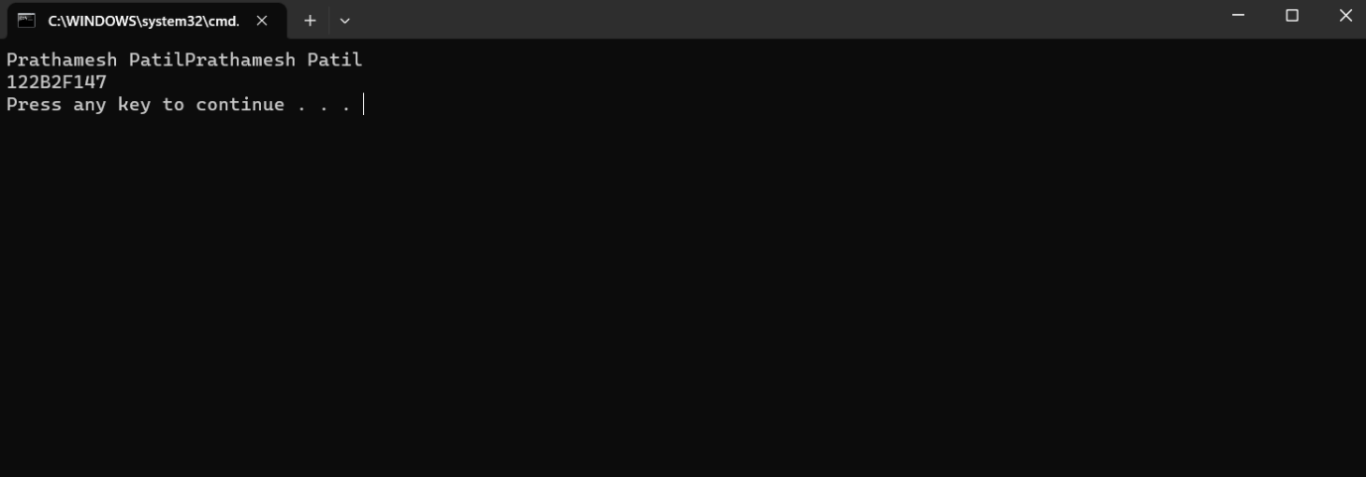OUTPUT: